# Financial Responsibility

Adopted dogs come with their vaccinations, but the dog’s health will always be something that needs to be kept in mind.

Dogs will chronically need heartworm medication, vaccines, city licenses, and the occasional check-up. Just like with children, you should have money set aside to take care of your dog’s health.

Precautions can help reduce the medical costs of your dog. Keeping the dog on a healthy diet, preventing them from chewing or swallowing foreign objects, and maintaining a healthy weight will all help lower medical bills on your pet.

The breed of dog should also be considered when thinking about your finances. Pure breeds are more likely to get diseases or require specific types of care, when you’re on a budget, a mixed breed dog can help keep your costs low.





## Why you should adopt

Dogs have always been known as man’s best friend. In fact, you’d probably be hard pressed to find someone who just couldn’t stand them; I mean after all, we don’t call it a puppy-face for nothing.

Owning a shelter dog just adds to the benefits. Mixed breed dogs are often healthier, and by adopting, you help deter back-yard breeders and puppy mills, while reducing the number of homeless dogs.

Dogs can provide great companionship, protection, and even provide aid, but even the most low maintenance breeds require love and attention.

Five things to think about before adopting



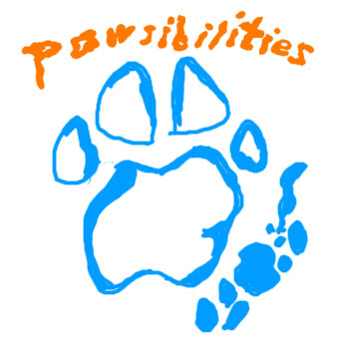

Pawsilibilites

An IB CAS group

From Coronado High

http://elpasopawsibilities.wordpress.com/

# The Pawsibilities’ Dog Adoption

## Guide

## Time Commitment

### 

Before getting a dog, realize the amount of time and effort that will need to go into taking care of it.

Dogs need to be exercised. Whether it’s biking, walking, or swimming, dogs should get at least half an hour of exercise every day. If you do not have the time to walk your dog, you should consider a dog-walker and account for it properly in your budget.

The other time consideration is the length of the dog’s life. If you are not prepared to take care of your dog for 8-12 years, a dog may not be the best pet for your family.

### Selecting a Dog

Dogs, like people, have different personalities and characteristics that may make them a good or bad match for your family.

Things to keep in mind:

1. The size of the dog (You should get a dog that can comfortably live in your home)
2. The gender of the dog
3. The breed of the dog

And…

1. The age of the dog

If you do not have a yard, it is best to get a small dog. Likewise, male dogs tend to be more aggressive and territorial and therefore are not as well suited for small children. While older dogs tend to be more calm and tolerant with children, high- energy puppies can be a good match for an athlete. It is always best to get an expert opinion when matching your family to a dog. Oftentimes, shelter managers will help match families to their ideal dog, and with their experience, can make a match that will last a lifetime.

# Spaying/Neutering and Pet Laws

Most shelters spay and neuter their animals before adoption, but should you get a dog from a breeder or rescue one off the street, getting your dog spayed and neutered is very important. Without these precautions, the dog population would be overwhelming and the number of homeless dogs would be incurable.

Laws that require vaccinations and micro-chipping are also important to know and obey. Your dog should always meet city and state requirements, which include yearly license renewals and tri-yearly vaccinations.

### Check out your local shelter

Once you know that you’re prepared to adopt, visit a local shelter. Volunteers and managers can help you make your decision. Shelters will also have information available about how to go about adopting, and what the latest laws on adoption and pet ownership are. Visiting local shelters will expose you to hundreds of dogs and allow you to meet and greet with them so you can get a feel for what kind of dog you’re looking for. When you’re ready, you’ll be able to find a dog that’s the right match for you and your family.





